Course Physics
Laboratory Report


Experiment Title: Determining resistances using a Wheatstone bridge

Name of student: Guliyeva Aychin
Group number: CE 22.2
Team number:07

Experiment carried out:11 March
Lab report submitted:2 April

Supervisor: Associate Prof.G.Najafov

Synopsis
The main aim of this report is to provide a detailed explanation of the resistance measurement procedure using a wheatstone bridge,as carried out by group-07.The experiment involves the utilization of a Wheatstone bridge to determine resistance .Furthermore,this report require the various calculations sourced from laboratory leaflets.Additionally,any challenges or issues encountered during the experiment will be addressed.

Intoduction
The aim of our laboratory experiment is to measure the resistance of Rx by comparing it to a precisely known resistance,represented as R.In essence,we use the accurately determined value of R as a reference to determine whether the resistance of Rx corresponds to the value of R. Our methodology relies on verifying whether the results obtained from this comparison same with the values calculated from solving the pertinent equations.

Theory

During the experiment,we use a variable but well-known resistance system alongside another resistance denoted as R.Employing the null balance method,we can accurately determine the precise resistance of Rx. Subsequently, our analysis involves a comparison of the obtained results by applying the equations provided below.

- Rx=$\frac{s1}{s2}$ *R

The resistance determination, accomplished via the null balance, remains unaltered by the applied current and is equally achievable with non-stabilized power sources. To improve precision in our measurements, it's advantageous to maintain equal lengths for the wire sections, s1 and s2, achieved by splitting the wire at its midpoint. This strategic modification enables a more accurate comparison and assessment of values during the resistance measurement procedure. Hence, ensuring the alignment of both sections' lengths, s1 and s2, emerges as a crucial element in maximizing the accuracy of our experimental results.So,

- Rx=R
In this configuration, the pilot wire is divided into two sections, designated as s1 and s2, by a sliding contact. By introducing Rx and R into the circuit and observing with an ammeter acting as a null indicator, our objective is to achieve a current balance of 0.

Experimental techniques

Apparatus
- 1 Demonstration bridge, 1 m long.........................536 02
- 1 Measuring resistor 10 Ω, 4 W............................536 121
- 1 Measuring resistor 100 Ω, 4 W..........................536 131
- 1 Measuring resistor 1 kΩ, 4 W............................536 141
- 1 Resistance decade 0 ... 1 kΩ.............................536 776
- 1 Resistance decade 0 ... 100 Ω..........................536 777
- 1 Resistance decade 0 ... 10 Ω............................536 778
- 1 Resistance decade 0 ... 1 Ω..............................536 779
- 1 DC power supply 0...+/- 15 V.............................521 45
- 1 Galvanometer C.A 403......................................531 13
- 3 Connecting leads, 50 cm, black.........................501 28
- 1 Pair of cables, 1 m, red/blue..............................501 46

Setup and carrying out the experiment:
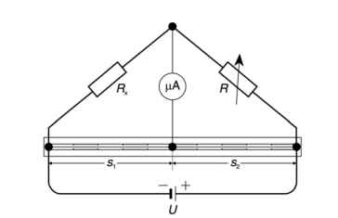

Initiate the experimental setup by precisely determining the lengths of the wire sections, s1 and s2. At the resistance decades,set R=1/2 Rx.Subsequently,switch the DC power supply,fixing the voltage at 1V.In the experiment,resistance values of R are 10,100,1000 ohms .Following these configurations,ammeter indicates I=0 with the lengths of s1 and s2.This zero-current condition serves as a crucial indicator during the experiment.Conclude the setup phase by applying rules to find the value of Rx under the specified conditions.

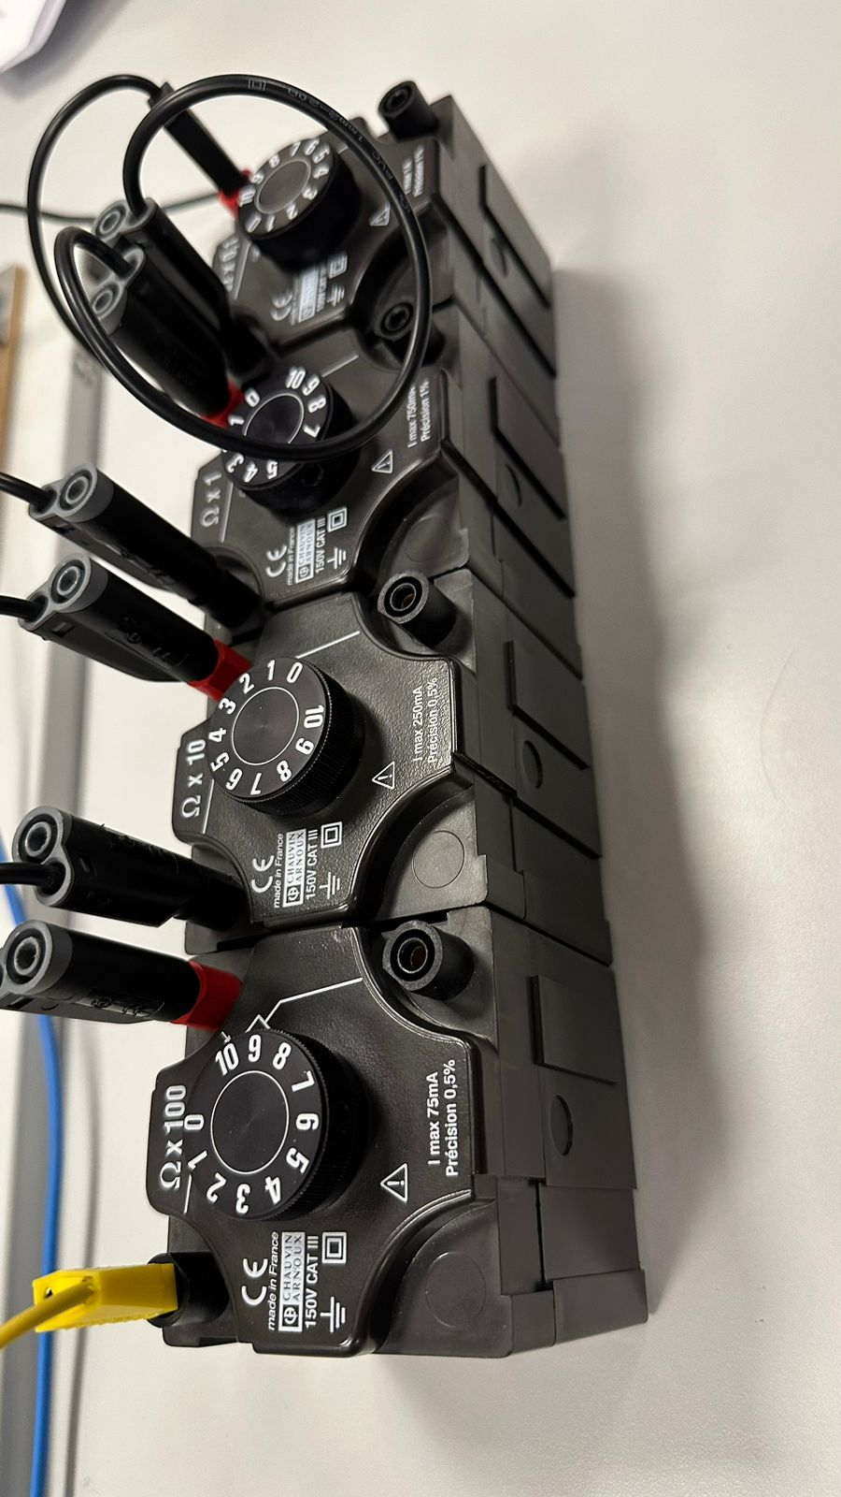

Achieve a null balance by adapting the resistance decades
Ensure that wire lengths are uniform by cutting the wire at the midpoint and assigning 50 cm to both sections, labeled as s1 and s2. Attach a 10 Ω measuring resistor and set up an appropriate arrangement for the resistance decades. Set the power supply to a voltage of 1 V. Adjust the resistance decades to achieve a null balance, indicated by the ammeter showing I = 0 A within the smallest measuring range.

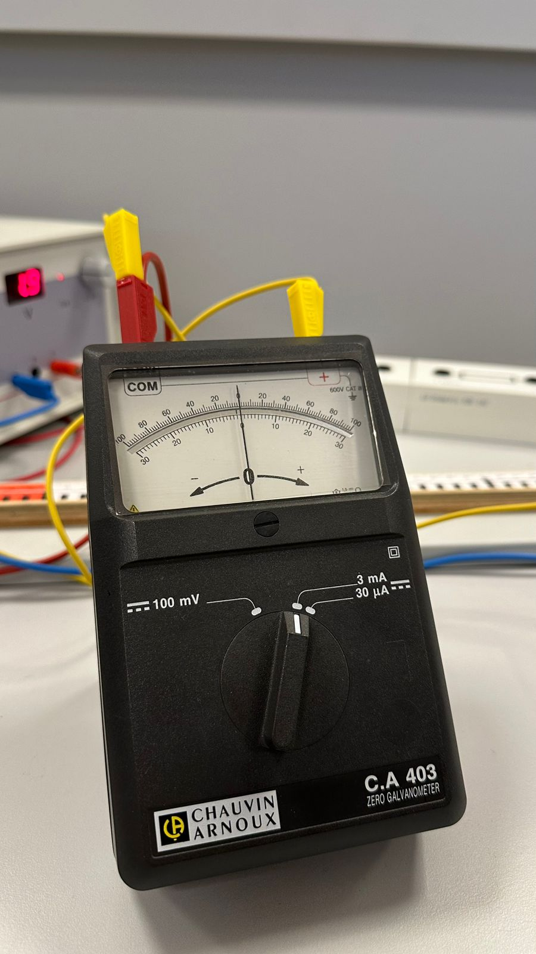

Results-Experimental and derived:
Following the provided instructions, we executed the experiment, yielding results that are essential for determining the resistance of Rx.

Results defined from the experiment:
R(Ω) | S1(cm) | S2(cm) | Rx(Ω)
10 | 50 | 50 | 12
 | 60 | 40 | 19
 | 40 | 60 | 8
100 | 50 | 50 | 130
 | 60 | 40 | 190
 | 40 | 60 | 80
1000 | 50 | 50 | 1111
 | 40 | 60 | 860
 | 30 | 70 | 600

Results derived from formulas:

R (Ω) | S1(cm) | S2(cm) | Rx (Ω)
10 | 50 | 50 | 10
 | 60 | 40 | 15
 | 40 | 60 | 6.67
100 | 50 | 50 | 100
 | 60 | 40 | 150
 | 40 | 60 | 66,7
1000 | 50 | 50 | 1000
 | 40 | 60 | 666,7
 | 30 | 70 | 428,6

Discussion of result
Hence, it is obvious that we successfully apply the equations for each scenario, accurately determining the implicit Rx. Throughout each phase, we systematically varied the lengths s1 and s2 as well as R to observe and ascertain Rx under null balance conditions. However, discrepancies between experimentally derived values and those obtained from equations were noted. Nonetheless, the values obtained through both calculation and experimentation are consistent, suggesting that any minor discrepancies may be attributed to factors such as temperature fluctuations, connection issues, and wire resistance. In summary, our experiment was successfully conducted.
Conclusion
Despite facing a few obstacles, our experiment achieved its goals effectively. We diligently recorded necessary data in the designated table, although there were some slight inaccuracies.

Reference
Laboratory leaflets, BHOS laboratory.

